Final Report

1. Introduction
The real estate market is influenced by various factors such as house age, renovation status, number of bedrooms and bathrooms, and overall size. This project aims to analyze housing market trends and visualize key insights using Tableau to better understand how different features impact sale prices.

1.1. Project overviews
The dataset contains Transformed housing data and 21,609 house sale records, including Property features such as Sales price, area, bedrooms, bathrooms, floors and location. There are a total of 31 columns, out of which Sale Price can be supposedly taken as a dependent variable. The other variables are different features, locations and date, etc. regarding the houses. This project, "Visualizing Housing Market Trends: An Analysis of Sale Prices and
Features using Tableau," aims to explore and analyze housing market trends using the Transformed Housing Data 2 dataset from Kaggle. The objective is to identify key factors influencing house prices, such as location, size, number of bedrooms, bathrooms, floors and basement area.
By leveraging Tableau, the project will create interactive dashboards, story, bar chart, histogram, summary dashboard to visualize patterns, compare regional price variations, and gain insights into how different features impact house sale prices. The analysis will help in making data- driven decisions for buyers, sellers, and real estate professionals.

1.2. Objectives
- Identify key factors influencing house prices.
- Analyze the effect of renovations on property value.
- Explore the distribution of house sales across different price ranges.
- Create interactive Tableau dashboards to present findings effectively.
1

2. Project Initialization and Planning Phase

2.1. Define Problem Statement

Problem  Statement  (PS) | I am (Customer) | I’m trying  to | But | Because | Which makes me feel
PS-1 | A first-time homebuyer who wants to make an informed decision | Find a home within my budget that meets my needs | The available market data is difficult to interpret and scattered across multiple sources | There is no  centralized, easy- to-use tool that visualizes housing trends based on  historical sales data | Confused and  overwhelmed, making me hesitant to proceed
PS-2 | A real  estate investor looking for high-return properties | Identify profitable properties  based on  price trends and key influencing factors | Existing datasets require extensive manual analysis and lack clear  insights | No interactive visualization tool allows me to compare property appreciation trends effectively | Frustrated and uncertain about making investment decisions
PS-3 | A real estate agent aiming to assist clients efficiently | Provide accurate and  insightful  recommend  ations based on market  data | The data is time- consuming to analyze and spread across various reports | There is no comprehensive  tool to aggregate and visualize pricing trends for quick  insights | Less efficient, unable to provide quick, data- backed advice  to clients
2

2.2 Empathy Map Canvas

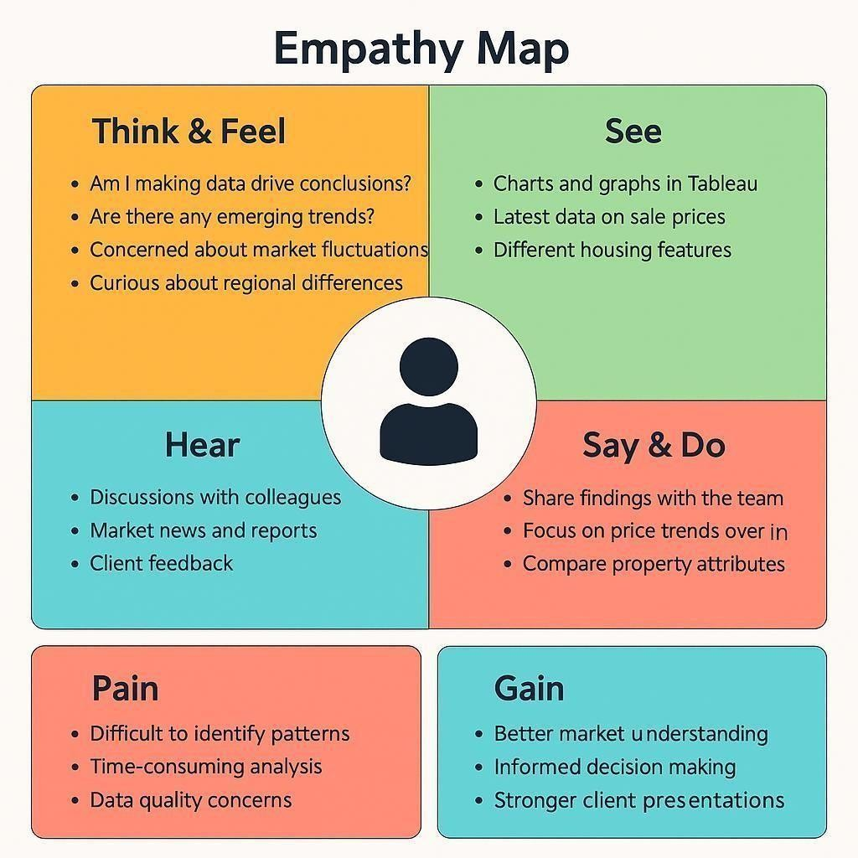

2.3 Brain Storming
Step 1: Team Gathering, Collaboration and Problem Statement
Our team collaborated to identify pressing challenges in the real estate market, particularly in understanding how various property features influence housing sale prices. After exploring themes like housing affordability, real estate investment planning, urban development, and smart property insights, we narrowed down our focus to uncover actionable insights hidden in housing data. The objective was to visually explore trends using Tableau that would help buyers, sellers, investors, and policy makers understand patterns of sale prices based on features like area, bedrooms, renovation status, condition, location (zipcode groups), and more. Problem Statement:

4 | Compare prices for renovated vs. non-renovated homes | Renovation Analysis
5 | Group insights by Zipcode Clusters | Geographical Comparison
6 | Analyze house condition vs. price using dummy variables | Quality-Based Pricing
7 | Add calculated field: TotalAreaSqft | Data Preparation
8 | Create SalePriceBin with 100k intervals | Binning / Categorization
9 | Use Tableau dashboard to combine insights | Dashboard Design
10 Build a Story in Tableau for narrative Storytelling & Reporting
How can housing sale price trends and property characteristics be visualized and analyzed using Tableau to identify patterns, improve buyer/seller decision-making, and uncover insights that support strategic real estate planning?
Team Members:
- Team Leader: Kalla Eswari Rama Satwika
- Team Member: Anukuli Padmavathi
- Team Member: Abbireddy UshaSri
- Team Member: Bakki Keerthi
- Team Member:Rajmahendravarapu Satyasri

Step 2: Brainstorming, Idea Listing and Grouping

S.No Idea Description Category
- Visualize average sale price by SalePriceBin Pricing Insights
- Analyze impact of number of bedrooms on sale price Property Features
- Explore relationship between Total Area and Price (scatter plot) Size-Based Pricing
S.No Idea Description Category
- Embed Dashboard in Web Application using Flask Deployment & Integration
- Add filters for Bedrooms, Condition, Renovation in Dashboard Interactive Exploration

Step 3: Idea Prioritization Table

S.No Idea Description Impact Feasibility Priority
1 | Visualize average sale price by SalePriceBin High Easy | High
2 | Analyze impact of number of bedrooms on sale price High | Easy High
3 | Explore TotalArea vs Price (scatter plot) High Easy High
4 | Compare prices for renovated vs. non-renovated homes High | Medium | High
- Group insights by Zipcode Clusters Medium Medium Medium
- Analyze house condition vs. price High Medium High
- Add calculated field: TotalAreaSqft Medium Easy High
- Create SalePriceBin with 100k intervals Medium Easy High
- Use Tableau dashboard to combine insights High Easy High
- Build a Story in Tableau High Medium High
- Embed Dashboard in Web Application High Hard Medium 12 Add filters for Bedrooms, Condition, Renovation Medium Easy Medium

3. Requirement analysis

3.1 Customer Journey map

Customer Journey Map: Housing Market Trends Dashboard

Stage | Touchpoints |  | Pain Points & Emotions |  | Opportunities User Goals
Awareness | - Sees  dashboard via social media, newsletter, Tableau Public  - Reads title/summary |  | Unclear if  Curious, dashboard is  Interested relevant |  | Attract Use benefit-driven interest and  titles, visual  clarify  thumbnails purpose
Actions & Experience

- Clicks dashboard
link Understand
Engaged, Overwhelmed by Add guided
Consideration - Reads the dashboard
Cautious layout, unsure walkthrough,
introduction, explores and its where
layout to start simplify navigation
features
- Uses filters for location, price, features Excited,
- Views charts Inquisitive
(bar, scatter, pie, etc)

- Exports visuals
- Shares dashboard
Satisfied,
- Bookmarks or Confident
downloads insights

- Subscribes for updates Loyal,
- Revisits for new
Empowered
data
- Leaves feedback

Add example Discover
Filters not intuitive,
Exploration charts slow to load queries,
improve valuable speed insights

7

3.2 Solution Requirement
Functional Requirements (FRs)
Decision  Retention | Limited export options or unclear findings formats  No update notifications, feedback unacknowledged | Enable easy download/share, offer export guides  Enable email updates, actively respond to feedback | Preserve and share  Stay informed and engaged
FR
No. | Functional Requirement (Epic) Sub Requirement (Story / Sub-Task)
FR-1 | Data Import | - Import data from CSV  - Enable live database integration (MySQL)
FR-2 | Data Cleaning & Transformation | - Handle missing values  - Add calculated fields like Year, Lockdown
FR-3 | Data Visualization | - Create Tableau worksheets - Build multiple dashboards  - Enable filtering by region, year
FR-4 | User Interaction | - View comparative bar charts
 |  | - Analyze pre/post-lockdown trends
 |  | - Role-based views for Analyst, Policy Maker,
FR-5 | User Access | Developer
 |  | - Download/export options
FR-6 | Feedback Loop | - Allow stakeholder feedback and change requests
- Implement revision cycles

Non-Functional Requirements (NFRs)

features/modules 3.3 Data Flow Diagram

NFR Non-Functional
No. Requirement  NFR-1 Usability  NFR-2 Security  NFR-3 Reliability  NFR-4 Performance  NFR-5 Availability  NFR-6 Scalability | Description  Dashboard must be intuitive with clear filters, legends, and guided walkthroughs  Implement role-based access and secure backend/database connectivity  System must handle unexpected data formats and maintain high accuracy  Ensure fast loading and responsive interaction across all dashboard elements  Dashboard should be accessible across browsers/devices with minimal downtime  Should scale for large datasets and support additional
A Data Flow Diagram (DFD) is a traditional visual representation of the information flows within a system. A neat and clear DFD can depict the right amount of the system requirement graphically. It shows how data enters and leaves the system, what changes the information, and where data is stored.
- Data collected from POSOCO in CSV format.
- Cleaned and transformed, with calculated fields like Year and Lockdown.
- Visualizations built in Tableau using multiple worksheets.
- Users review the dashboard and may request changes.
- Final version archived after approval.

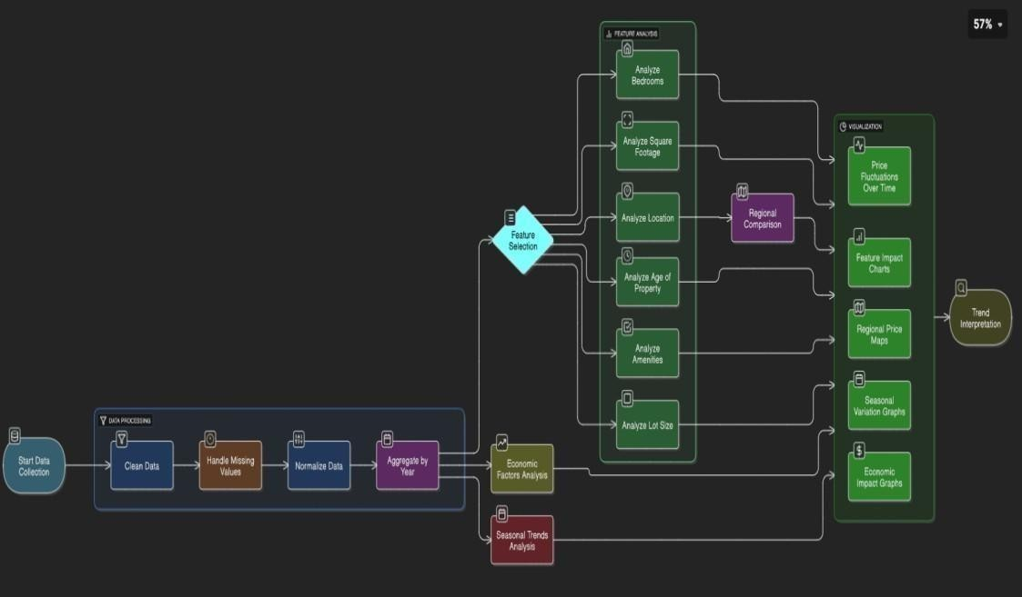
User Stories Table:

Functional User
Acceptance
User Type Requirement Story User Story / Task Priority Release
Criteria
(Epic) Number

As a user, I want to I can filter and
View
Analyst / view electricity view charts for Sprint-
Electricity USN-1 High
Policymaker usage trends by specific regions 1 region and year. and
Trends years.

As a user, I want to I can view bar
compare top and charts with top N Sprint- Analyst Compare States USN-2 Medium
bottom electricity- and bottom N 1 consuming states. states.

I can view
As a user, I want to monthly and
Sprint-
Forecast analyze seasonal quarterly High
Policy Maker USN-3 2
Planning variations in usage. consumption
trends.

As a user, I want to A before-after
Energy View Impact of compare electricity lockdown chart is Sprint-
USN-4 High
Consultant Lockdown usage before and available for 2 after lockdown. selection.

As a user, I want Data refreshes

Developer Connect Data USN-5

Developer Export Insights USN-6 connected to a live from MySQL to 2
database. Tableau.

3.4 Technology Stack
the dashboard to be automatically Sprint-
Medium
As a user, I want to
I can download
export dashboard Sprint-
dashboards as Low
views for 3
images or PDFs.
presentations.

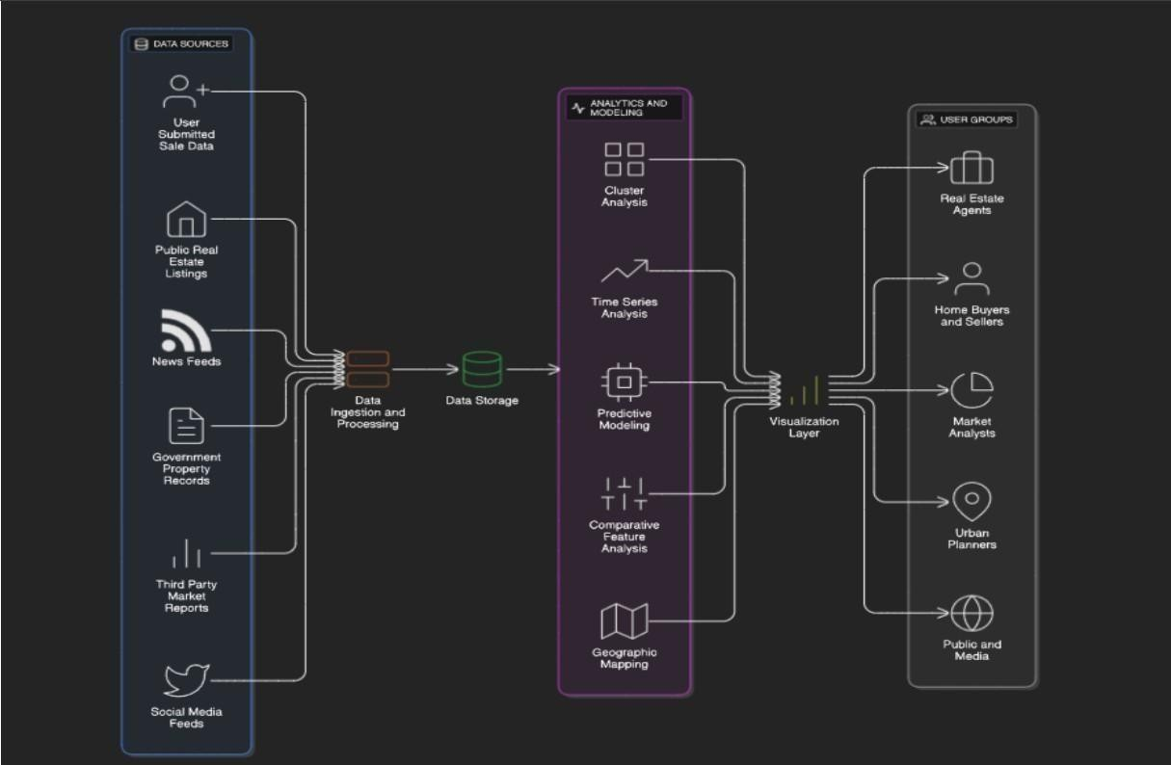

4. Project design

4.1 Problem Solution Fit

The Problem-Solution Fit simply means that you have found a problem with your customer and that the solution you have realized for it actually solves the customer’s problem. It helps entrepreneurs, marketers and corporate innovators identify behavioral patterns and recognize what would work and why.
Purpose:
❑ Solve complex problems in a way that fits the state of your customers.
❑ Succeed faster and increase your solution adoption by tapping into existing mediums and channels of behavior.
❑ Sharpen your communication and marketing strategy with the right triggers and messaging.
❑ Increase touch-points with your company by finding the right problem-behavior fit and building trust by solving frequent annoyances, or urgent or costly problems.
❑ Understand the existing situation in order to improve it for your target group.

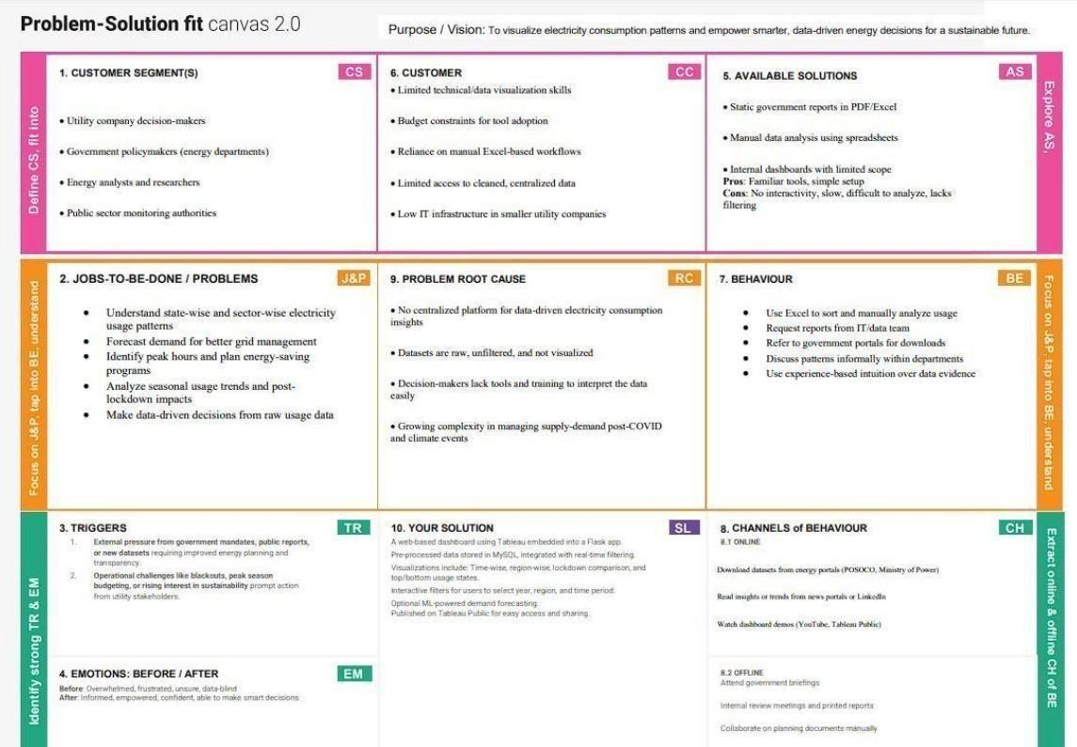

4.2 Proposed Solution

Proposed Solution Template
S.No. Parameter Description
The real estate market involves vast and complex datasets on housing
1 Problem features and sale prices. These datasets are often underutilized due to lack Statement of effective visualization, making it difficult for buyers, sellers, and analysts to draw insights or forecast trends.
Our solution transforms static housing datasets into interactive, insightful visualizations using Tableau. The project involves cleaning and 2 Idea / Solution transforming the data, creating calculated fields and KPIs, and developing
Description
a dashboard that highlights key trends, comparisons, and location-based
analyses. The solution is deployed via a Flask web app.
This project leverages Tableau’s powerful visual capabilities to go beyond basic data analytics. By combining calculated fields, condition
- Novelty / segmentation, and geographic mapping, the dashboard offers a dynamic Uniqueness exploration of how features like bedrooms, area, renovation, and location
influence housing prices.
This solution enables real estate buyers, sellers, agents, and market
^{Social Impact /} researchers to make informed decisions. It improves housing transparency,
- Customer
supports better urban planning, and enhances user engagement with clear
Satisfaction visuals and actionable insights.
This dashboard can be scaled and offered as a subscription-based SaaS tool Business Model to real estate companies, market research firms, or housing consultancies.
- (Revenue
Advanced forecasting modules, API integrations, and custom dashboards
Model) can be monetized as premium features.
The system is designed to be scalable and adaptable. It can incorporate new
Scalability of the datasets (like rental trends or economic indicators), extend to new regions
6
Solution or cities, and integrate with ML models for price predictions, thereby offering long- term growth potential.

4.3 Solution Architecture

Solution architecture is a complex process – with many sub-processes – that bridges the gap between business problems and technology solutions. Its goals are to:
- The architecture separates data preprocessing, storage, visualization, and UI layers—making it easy to maintain, scale, and enhance.
- Cleaned data from MySQL is visualized using Tableau dashboards, offering region-wise, year- wise, and seasonal insights with filtering capabilities.
- Dashboards are embedded into a Flask-based web interface, allowing end users to interact with visual data through a user-friendly portal.
- The solution supports future extensions like forecasting models and can be deployed locally or on cloud platforms like Heroku or AWS.

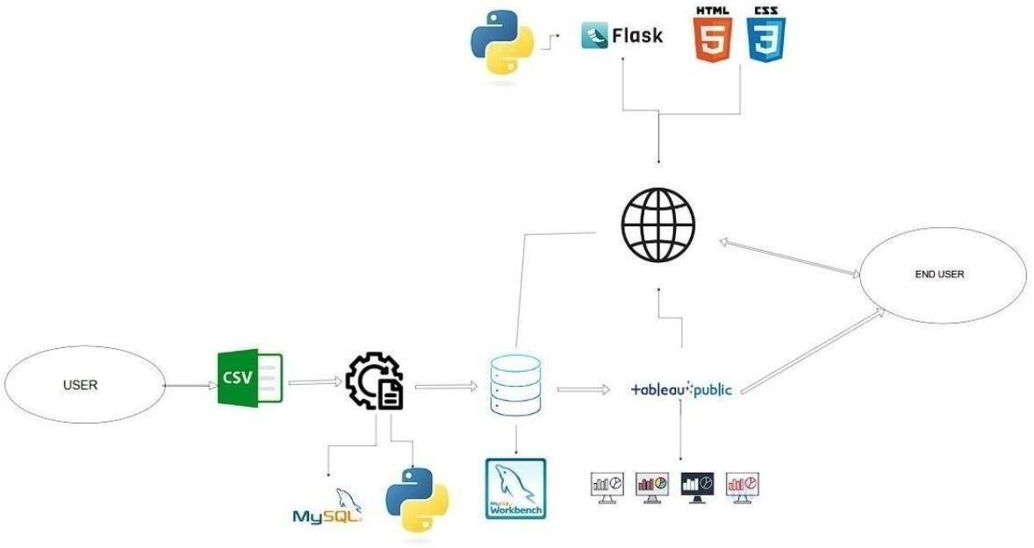

5. Project planning & scheduling

5.1 Project Planning

User
Sprint Epic |  | Story User Story / Task Points Priority Assigned To
 |  | No.
Sprint-  Data Setup  1 |  | As a user, I can upload housing data  USN-1 3 in  CSV format |  | High A.UshaSri
Sprint-  Data Cleaning  1 |  | As a developer, I can clean and  USN-2 4  preprocess housing data in Tableau |  | High K.E.R.satwika
Sprint-  Field Creation  1 |  | As a user, I can create calculated  USN-3 2 fields like TotalAreaSqft |  | Medium A.UshaSri
Sprint-  Price Binning USN-4  1 |  |  | As a user, I can create SalePriceBin  2 for grouping houses Medium A.Padmavathi
Sprint- Data  USN-5  2 Visualization |  |  | As a user, I can create sheets with High A.Padmavathi  5 charts: price vs features
Sprint- Dashboard  2 Creation USN-6 |  |  | As a user, I can build an interactive  3 High A.UshaSri  Tableau Dashboard with filters
Sprint- Dashboard  2 Styling USN-7 |  |  | As a user, I can style the dashboard K.E.R.satwika  2 for Medium K.E.R.satwika  better readability and navigation
Sprint-  Storytelling USN-8  3 |  |  | As a user, I can create a Tableau R.satyasri 2 Medium B.keerthi  Story showing insights step by step A.padmavathi
Sprint-  Flask Integration USN-9 3 |  |  | As a developer, I can embed  Tableau dashboard into a Flask web 4 app High R.satyasri  B.keerthi
3 Embed Testing USN-10 |  |  | As a user, I can test and review the print- K.E.R.satwika  2 Medium  embedded dashboard UI
Sprint- |  |  | As a team, we can prepare final
Documentation USN-11 3 High R.satyasri 4 project documentation
Sprint- Demo As a team, we can prepare and A.padmavathi
USN-12 2 Medium B.keerthi
4 Preparation rehearse a full demo walkthrough A.padmavathi Sprint- Bug Fixing / As a team, we can test the full
USN-13 2 Medium A.ushasri
4 Final QA system and fix visual/logic bugs

Project Tracker, Velocity & Burndown Chart
Sprin Total Story Poin DuratioStart Date End Date Points CompleteRelease Da

Sprint 11 | 4 Days 11 June 20214 June 20211 | 14 June 202
Sprint 10 | 4 Days 15 June 20218 June 20210 | 18 June 202
Sprint 7 | 4 Days 19 June 20222 June 2027 | 22 June 202
Sprint 7 | 4 Days 23 June 20226 June 2027 | 26 June 202

Velocity Calculation
Total Points Completed: 11 + 10 + 7 + 7 = 35
Total Duration: 4 + 4 + 4 + 4 = 16 days
Average Velocity = Total Points Completed / Total Days = 35 / 16 = 2.19 points/day
Burndown Chart Insight
- Initial Total Story Points: 35
- Sprint-wise burn (Remaining Points): _{o} After Sprint-1: 24 _{o}
After Sprint-2: 14 _{o} After Sprint-3: 7 _{o} After Sprint-4: 0

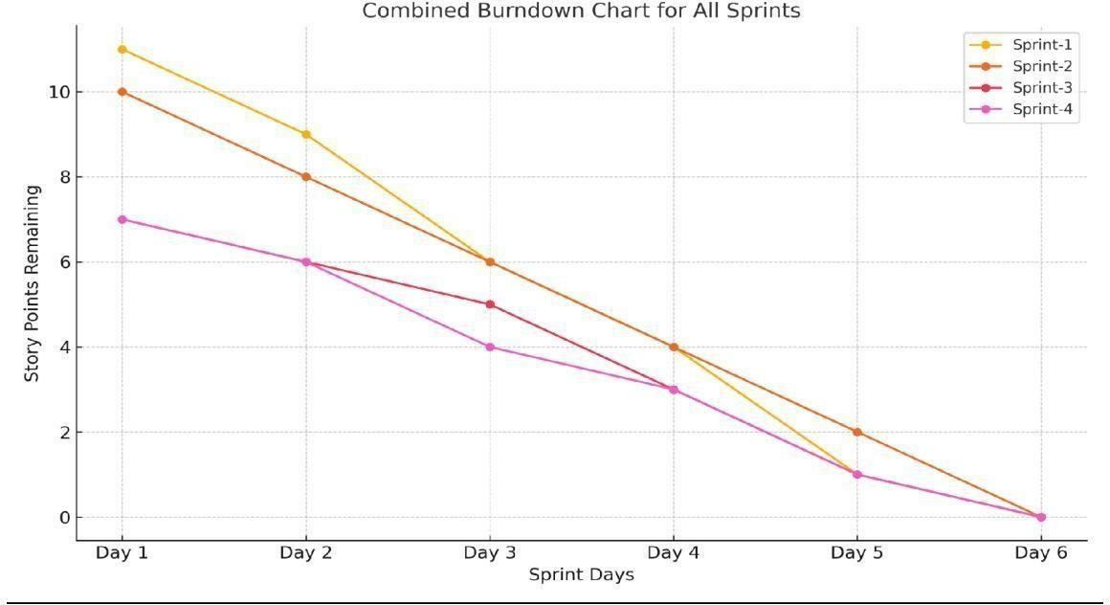

6. Functional and performance testing

6.1 Performance Testing

S.No | Parameter | Screenshot / Values

1. | Data Rendered | The dataset used contains housing sales data with fields such as Sale  Price, Number of Bedrooms, Bathrooms, Flat Area, Lot Area,  Basement Area, House Age, Condition, Renovation Status, Zipcode Group, and others. The data was provided in .csv format and include derived and transformed columns suitable for advanced analytics and visualizations in Tableau.
2. | Data Preprocessin | Before importing the data into Tableau, preprocessing was done usin Python (Pandas). The following steps were performed:  - Removed null or missing values.  - Renamed columns for clarity (e.g., “No of Bedrooms” →  “Bedrooms”).  - Created calculated fields like “TotalAreaSqft” (sum of flat, lo and  basement areas).  - Generated dummy variables for house conditions and renovation status.  - Transformed categorical fields to improve Tableau usability. The final cleaned dataset was stored and imported into Tableau for visualization.

3. | Utilization of Filters | Multiple filters were implemented in Tableau to improve interactivity and user exploration. These include:  - Number of Bedrooms  - Number of Bathrooms  - House Condition  - Renovation Status (Yes/No)  - Zipcode Group  - Sale Price Bins  These filters allow users to drill down and compare trends across different property types and regions.

4 | Calculated  Fields Used | Several calculated fields were created in Tableau to enhance analysis and interactivity:  - TotalAreaSqft → [FlatAreaSqft] + [LotAreaSqft] +  [BasementAreaSqft]  - SalePriceBin → Binning Sale Price into ₹100,000 intervals  - Condition_Excellent, Condition_Good, etc. → Dummy fields (0/1  - Ever_Renovated_Yes → Dummy field to identify renovated home  - AvgPrice → AVG([SalePrice]) for grouped insights  - HouseAge → Difference between year built and sale date if available  (or derived field if pre-calculated)  These fields enable comparisons across pricing, condition, and space utilization.

5 | Dashboard | 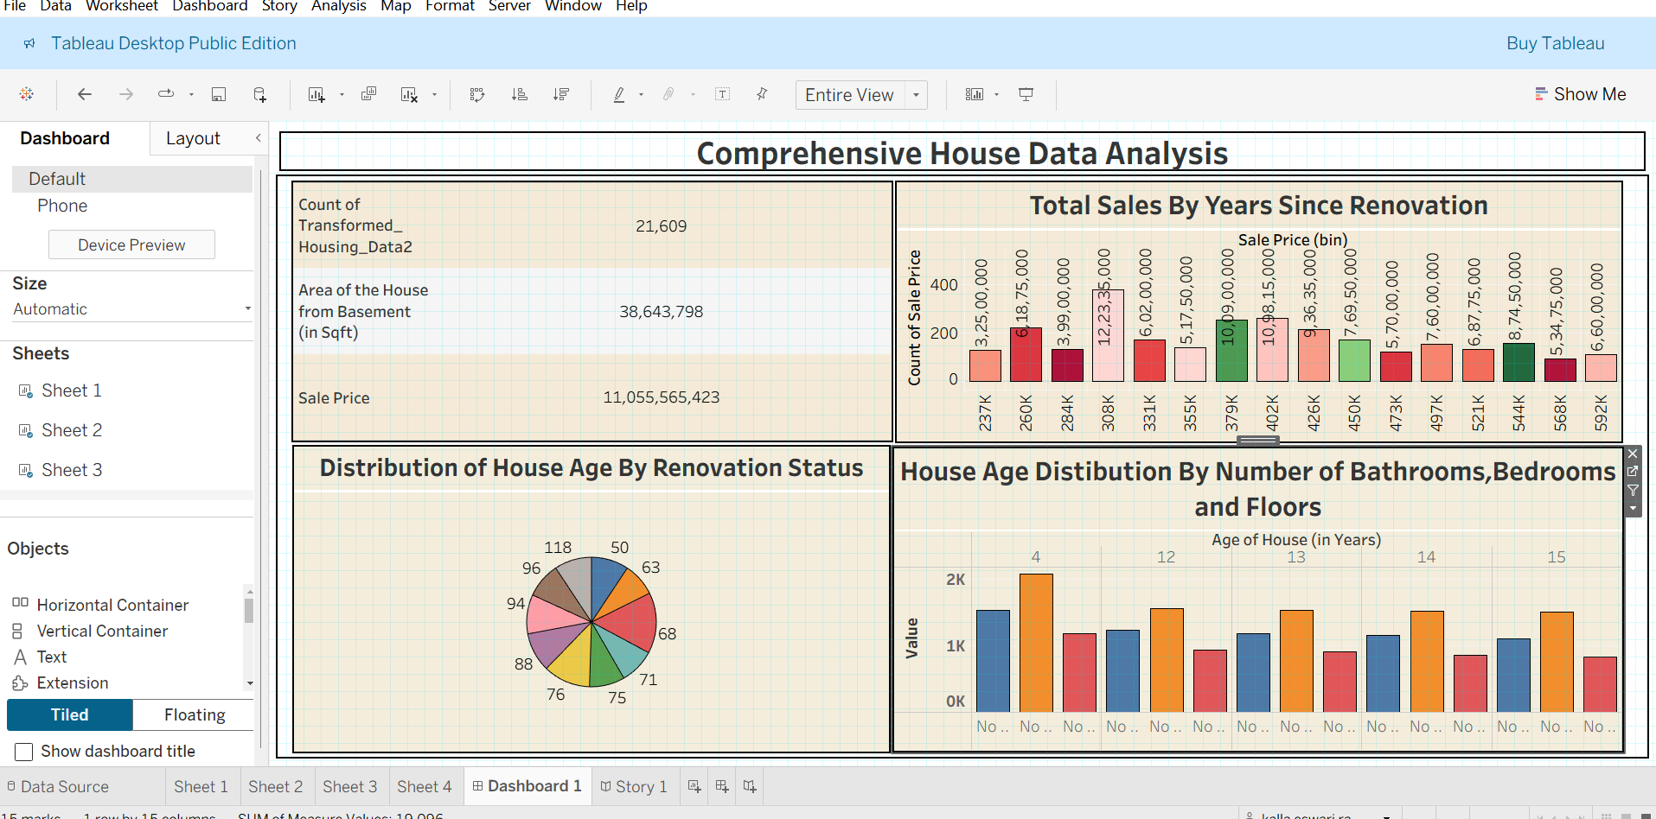

6 | Story Design | 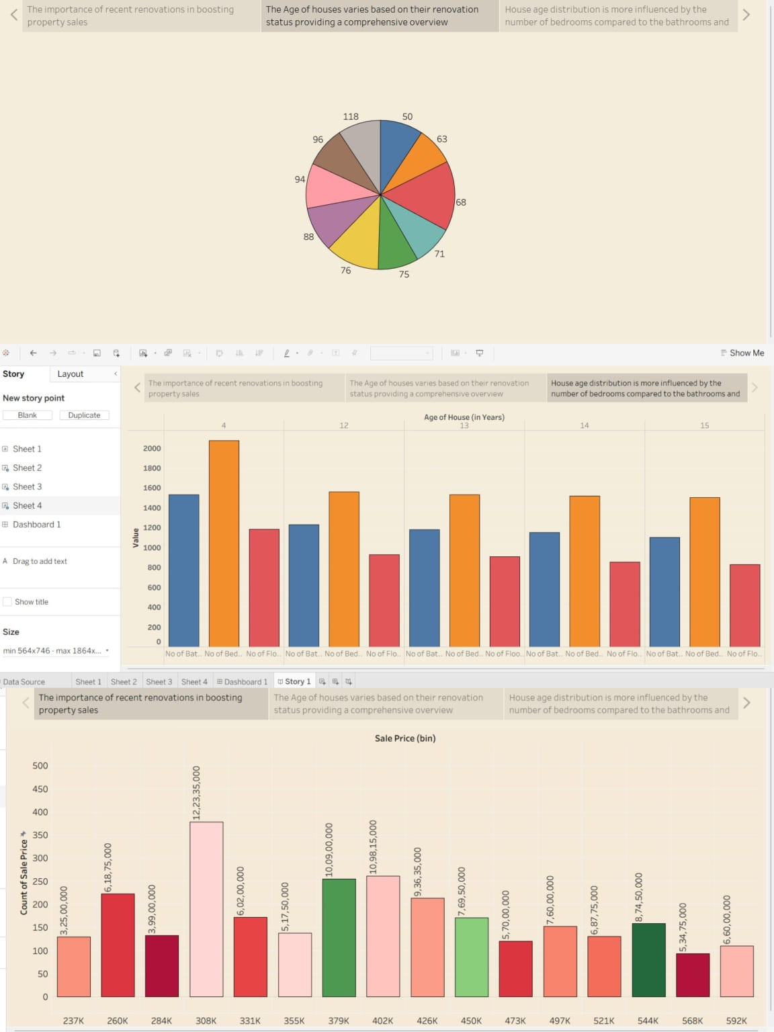

7. Results
7.1 Output Screenshots

Output of Sheet 1
Output of

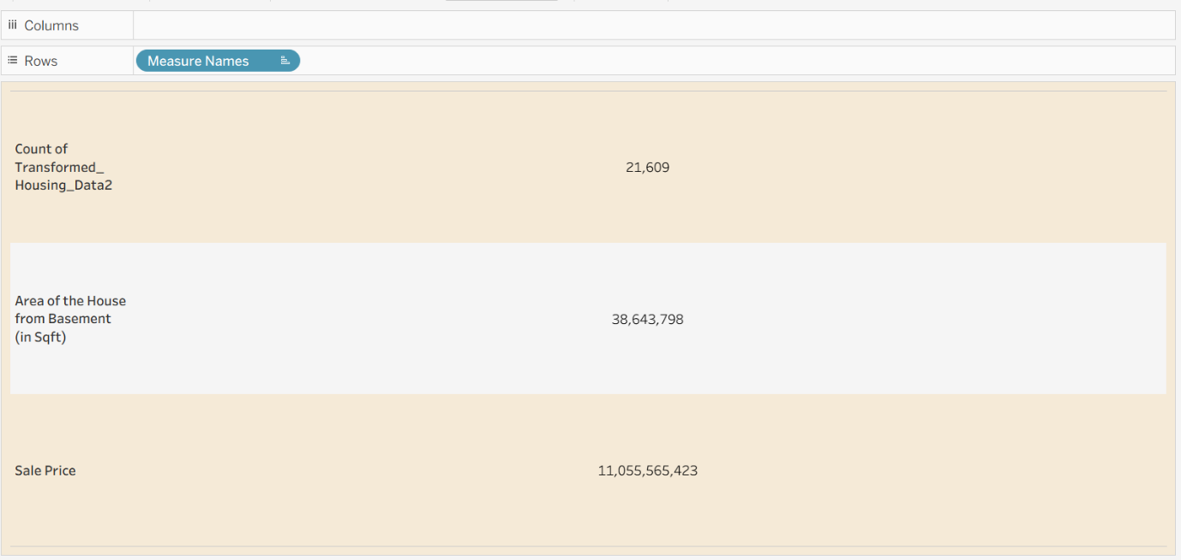

Output of Sheet 2

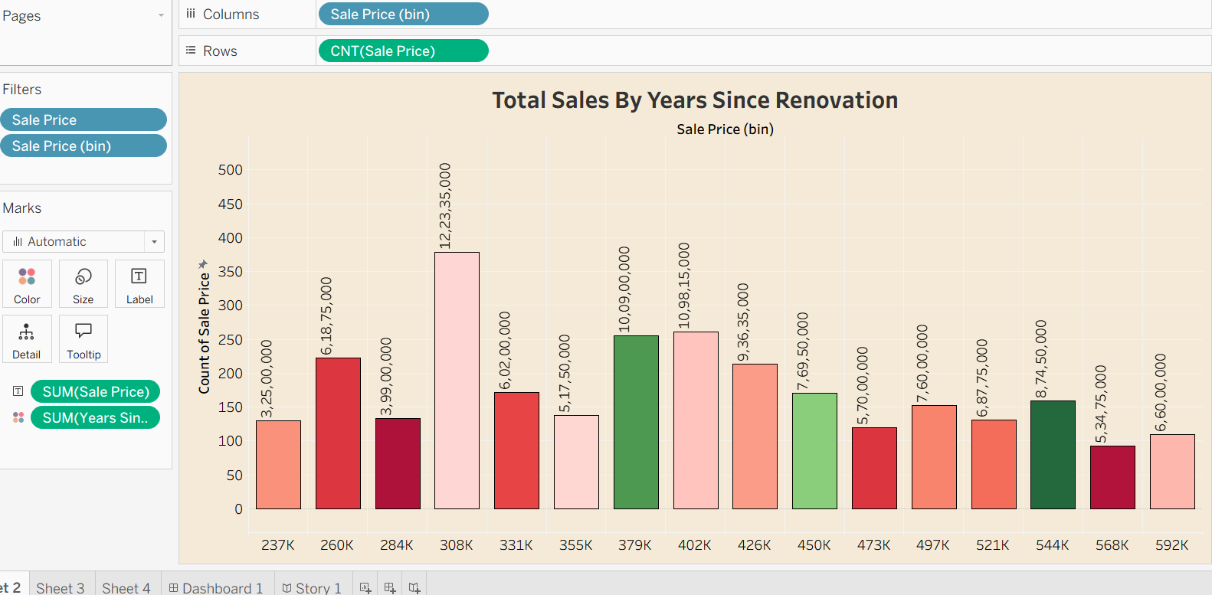
Sheet 3
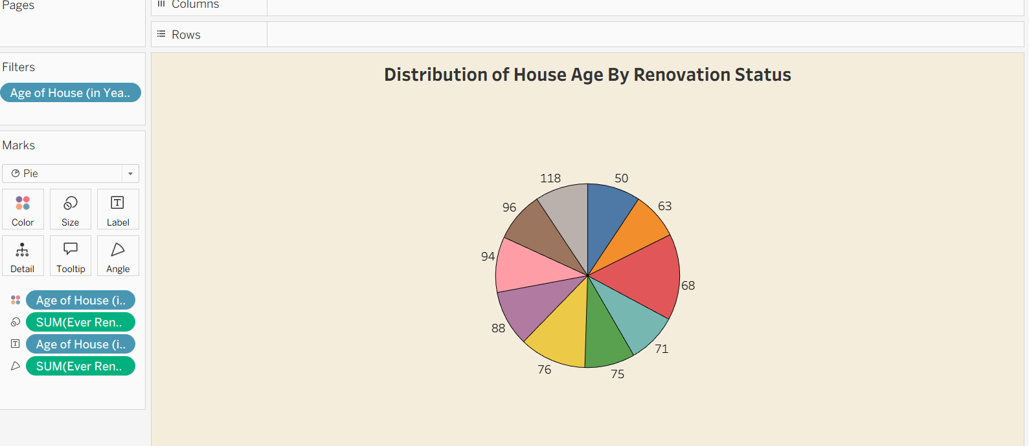

Output of Sheet 4

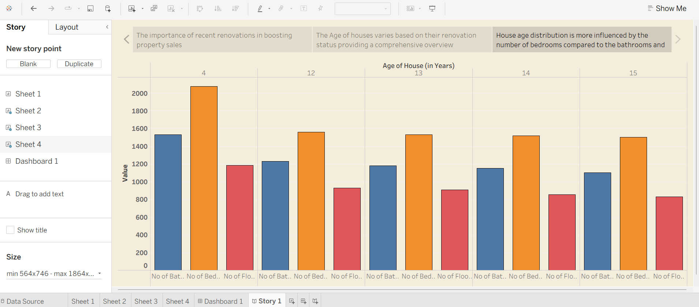

Sheet 7

Output of Dashboard



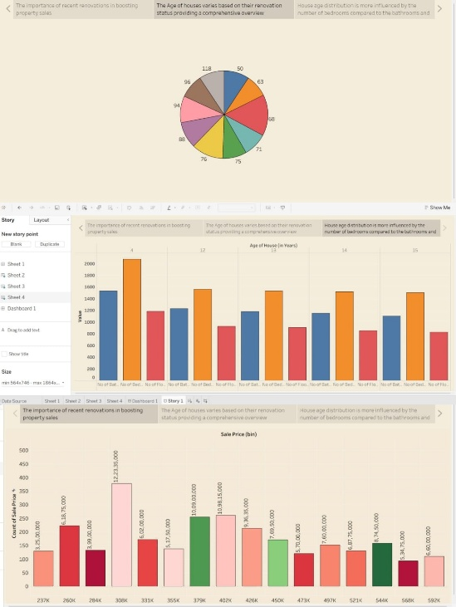

Tableau public link

https://public.tableau.com/app/profile/kalla.eswari.rama.satwika/vizzes

8. Advantages & disadvantages Advantages:
- Interactive Analysis:
The Tableau dashboard allows users to explore data with filters (e.g., bedrooms, renovation status, price bins), enhancing understanding through dynamic interactions.
- Informed Decision-Making:
Buyers, sellers, agents, and investors can make data-driven decisions by identifying which features (e.g., area, renovations, number of floors) impact property value.
- Data Storytelling:
The Tableau Story feature presents insights in a sequential, digestible narrative—great for business reports or stakeholder presentations.
- Geographic Visualization:
Zipcode grouping allows regional comparison of price trends and property types, revealing market opportunities and local disparities.
- Calculated Metrics & KPIs:
Metrics like Average Sale Price and Total Area improve business clarity and enable fast comparisons across categories.
- Web Accessibility:
Embedding the dashboard into a Flask web app increases accessibility—users can view it from any browser without needing Tableau Desktop.
- Modular & Scalable Design:
The project structure supports additional data (e.g., rental prices, future years), making it expandable to other regions or market conditions.
- Minimal Coding Required:
Most of the visualizations are created using Tableau’s drag-and-drop interface—making it ideal for analysts without deep programming expertise.

Disadvantages:
- Static Dataset Limitation:
The analysis depends on a preloaded CSV file; it doesn’t support real-time updates unless integrated with live databases or APIs.
- Tool Dependency:
The system relies on Tableau Public, which has limitations like no row-level security and requires dashboards to be public. 3. Learning Curve for Tableau:
While Tableau is user-friendly, new users may need time to understand calculated fields, filters, and advanced charting options.
- Limited Predictive Power:
This is a descriptive and visual analytics project—it does not use machine learning or predictive modeling to forecast housing prices.
- Browser Compatibility:
Older browsers or low-resolution screens may not render complex dashboards optimally, especially if not designed responsively.
- Manual Data Preprocessing:
Initial data cleaning, renaming, and transformation were done manually using Python or within Tableau, which might be error-prone at scale.
  - Conclusion:
The project "Visualizing Housing Market Trends: An Analysis of Sale Prices and Features using Tableau" successfully demonstrates how complex real estate data can be transformed into meaningful, interactive visual insights. By leveraging Tableau’s powerful visualization capabilities, we have made it easier for buyers, sellers, investors, and analysts to understand the key factors influencing house prices. Our dashboard enables quick comparisons based on features like number of bedrooms, renovations, house age, and geographic location. The integration with Flask provides a seamless web interface, enhancing accessibility and usability. Overall, this project bridges the gap between raw housing data and strategic real estate decision-making, allowing users to gain actionable insights with minimal technical expertise.

  - Future scope:
  - Live Data Integration:
Future versions can integrate live property listings or transaction data via APIs or real-time databases to provide up-to-date market insights.
  - Machine Learning Forecasting:
Incorporating regression models or time-series forecasting can help predict future housing prices based on historical trends and features.
  - Rental Market Visualization:
Extend the dashboard to include rental data analysis, enabling a broader comparison between buying vs. renting decisions.
  - Mobile Optimization:
Responsive design enhancements can be implemented to ensure the dashboard performs well across tablets and smartphones. 5. Advanced User Access Control:
By using Tableau Server or Tableau Online, dashboards can be secured with role-based access for different stakeholders.
  - Location Intelligence Enhancements:
Integration of geospatial data, satellite maps, or demographic overlays can improve location- based insights (e.g., school zones, crime rates).
  - Recommendation Engine:
Develop a recommendation system to suggest optimal property types using user-input filters.

11. Appendix

Source Code: index.html
<!DOCTYPE html>
<html lang="en">

<head>
<meta charset="utf-8">
<meta content="width=device-width, initial-scale=1.0" name="viewport">
<title>Index - Housing Trends Bootstrap Template</title>
<meta name="description" content="">
<meta name="keywords" content="">

<!-- Favicons -->
<link href="assets/img/favicon.png" rel="icon">
<link href="assets/img/apple-touch-icon.png" rel="apple-touch-icon">

<!-- Fonts -->
<link href="https://fonts.googleapis.com" rel="preconnect">
<link href="https://fonts.gstatic.com" rel="preconnect" crossorigin>
<link href="https://fonts.googleapis.com/css2?family=Roboto:ital,wght@0,100;0,300;0,400;0,500;0,700;0,900;1,100;1,300;1,400;1,500;1,700;1,900&family=Raleway:ital,wght@0,100;0,200;0,300;0,400;0,500;0,600;0,700;0,800;0,900;1,100;1,200;1,300;1,400;1,500;1,600;1,700;1,800;1,900&family=Inter:wght@100;200;300;400;500;600;700;800;900&display=swap" rel="stylesheet">

<!-- Vendor CSS Files -->
<link href="assets/vendor/bootstrap/css/bootstrap.min.css" rel="stylesheet">
<link href="assets/vendor/bootstrap-icons/bootstrap-icons.css" rel="stylesheet">
<link href="assets/vendor/aos/aos.css" rel="stylesheet">
<link href="assets/vendor/glightbox/css/glightbox.min.css" rel="stylesheet">
<link href="assets/vendor/swiper/swiper-bundle.min.css" rel="stylesheet">

<!-- Main CSS File -->
<link href="assets/css/main.css" rel="stylesheet">

<!-- =======================================================
* Template Name: Housing Trends
* Template URL: https://bootstrapmade.com/dewi-free-multi-purpose-html-template/
* Updated: Aug 07 2024 with Bootstrap v5.3.3
* Author: BootstrapMade.com
* License: https://bootstrapmade.com/license/
======================================================== -->
</head>

<body class="index-page">

<header id="header" class="header d-flex align-items-center fixed-top">
<div class="container-fluid container-xl position-relative d-flex align-items-center">

<a href="index.html" class="logo d-flex align-items-center me-auto">
<!-- Uncomment the line below if you also wish to use an image logo -->
<!-- <img src="assets/img/logo.png" alt=""> -->
<h1 class="sitename">Housing Trends</h1>
</a>

<nav id="navmenu" class="navmenu">
<ul>
<li><a href="#hero" class="active">Home</a></li>
<li><a href="#about">About</a></li>
<li><a href="#services">Dashboard</a></li>
<li><a href="#portfolio">Story</a></li>

<i class="mobile-nav-toggle d-xl-none bi bi-list"></i>
</nav>

<a class="cta-btn" href="index.html#about">Get Started</a>

</div>
</header>

<main class="main">

<!-- Hero Section -->
<section id="hero" class="hero section dark-background">

<img src="assets/img/hero-bg.jpg" alt="" data-aos="fade-in">

<div class="container d-flex flex-column align-items-center">
<h2 data-aos="fade-up" data-aos-delay="100">VISUALIZING HOUSING SALES TRENDS AND ITS TRENDS</h2>
<div class="d-flex mt-4" data-aos="fade-up" data-aos-delay="300">
<a href="#about" class="btn-get-started">Get Started</a>
</div>
</div>

</section><!-- /Hero Section -->

<!-- About Section -->
<section id="about" class="about section">

<div class="container">

<div class="row gy-4">
<div class="col-lg-6" data-aos="fade-up" data-aos-delay="100">
<img src="assets/img/about.jpg" class="img-fluid rounded-4 mb-4,.my_img" alt="Description of image" width="960" height="1080">
<h3>Visualizing Housing Market Trends: An Analysis of Sale Prices and Features using Tableau</h3>
<p>✓ The goal is to address challenges in understanding the factors that influence house prices and sales trends.</p>

<p>✓✓ By analysing comprehensive housing data, including the total sales by years since renovation, house age distribution by the number of bathrooms, bedrooms, and floors, and the impact of renovations on house age, the company aims to uncover key insights.</p>

<p>✓✓✓ Utilizing Tableau for this analysis, the objective is to visualize and interpret patterns in the housing market to inform strategic decisions, optimize pricing strategies, and enhance overall market competitiveness.</p>
</div>

</div>

</section><!-- /About Section -->

<!-- Services Section -->
<section id="services" class="services section">

<div class='tableauPlaceholder' id='viz1771438464724' style='position: relative'><noscript><a href='#'><img alt='Comprehensive House Data Analysis ' src='https:&#47;&#47;public.tableau.com&#47;static&#47;images&#47;Bo&#47;Book1_1_17713454550480&#47;Dashboard1&#47;1_rss.png' style='border: none' /></a></noscript><object class='tableauViz' style='display:none;'><param name='host_url' value='https%3A%2F%2Fpublic.tableau.com%2F' /> <param name='embed_code_version' value='3' /> <param name='site_root' value='' /><param name='name' value='Book1_1_17713454550480&#47;Dashboard1' /><param name='tabs' value='no' /><param name='toolbar' value='yes' /><param name='static_image' value='https:&#47;&#47;public.tableau.com&#47;static&#47;images&#47;Bo&#47;Book1_1_17713454550480&#47;Dashboard1&#47;1.png' /> <param name='animate_transition' value='yes' /><param name='display_static_image' value='yes' /><param name='display_spinner' value='yes' /><param name='display_overlay' value='yes' /><param name='display_count' value='yes' /><param name='language' value='en-US' /></object></div> <script type='text/javascript'> var divElement = document.getElementById('viz1771438464724'); var vizElement = divElement.getElementsByTagName('object')[0]; if ( divElement.offsetWidth > 800 ) { vizElement.style.width='100%';vizElement.style.height=(divElement.offsetWidth*0.75)+'px';} else if ( divElement.offsetWidth > 500 ) { vizElement.style.width='100%';vizElement.style.height=(divElement.offsetWidth*0.75)+'px';} else { vizElement.style.width='100%';vizElement.style.height='1277px';} var scriptElement = document.createElement('script'); scriptElement.src = 'https://public.tableau.com/javascripts/api/viz_v1.js'; vizElement.parentNode.insertBefore(scriptElement, vizElement); </script> </div><!-- End Section Title -->

<!-- Portfolio Section -->
<section id="portfolio" class="portfolio section">

<div class='tableauPlaceholder' id='viz1771438659923' style='position: relative'><noscript><a href='#'><img alt='Story 1 ' src='https:&#47;&#47;public.tableau.com&#47;static&#47;images&#47;6T&#47;6TK35Y725&#47;1_rss.png' style='border: none' /></a></noscript><object class='tableauViz' style='display:none;'><param name='host_url' value='https%3A%2F%2Fpublic.tableau.com%2F' /> <param name='embed_code_version' value='3' /> <param name='path' value='shared&#47;6TK35Y725' /> <param name='toolbar' value='yes' /><param name='static_image' value='https:&#47;&#47;public.tableau.com&#47;static&#47;images&#47;6T&#47;6TK35Y725&#47;1.png' /> <param name='animate_transition' value='yes' /><param name='display_static_image' value='yes' /><param name='display_spinner' value='yes' /><param name='display_overlay' value='yes' /><param name='display_count' value='yes' /><param name='language' value='en-US' /></object></div> <script type='text/javascript'> var divElement = document.getElementById('viz1771438659923'); var vizElement = divElement.getElementsByTagName('object')[0]; vizElement.style.minWidth='564px';vizElement.style.maxWidth='1864px';vizElement.style.width='100%';vizElement.style.minHeight='773px';vizElement.style.maxHeight='973px';vizElement.style.height=(divElement.offsetWidth*0.75)+'px'; var scriptElement = document.createElement('script'); scriptElement.src = 'https://public.tableau.com/javascripts/api/viz_v1.js'; vizElement.parentNode.insertBefore(scriptElement, vizElement); </script> </section><!-- /Portfolio Section -->

<div class="container copyright text-center mt-4">
<div class="credits">
<!-- All the links in the footer should remain intact. -->
<!-- You can delete the links only if you've purchased the pro version. -->
<!-- Licensing information: https://bootstrapmade.com/license/ -->
<!-- Purchase the pro version with working PHP/AJAX contact form: [buy-url] -->
</div>
</div>

</footer>

<!-- Scroll Top -->
<a href="#" id="scroll-top" class="scroll-top d-flex align-items-center justify-content-center"><i class="bi bi-arrow-up-short"></i></a>

<!-- Preloader -->
<div id="preloader"></div>

<!-- Vendor JS Files -->
<script src="assets/vendor/bootstrap/js/bootstrap.bundle.min.js"></script>
<script src="assets/vendor/php-email-form/validate.js"></script>
<script src="assets/vendor/aos/aos.js"></script>
<script src="assets/vendor/glightbox/js/glightbox.min.js"></script>
<script src="assets/vendor/purecounter/purecounter_vanilla.js"></script>
<script src="assets/vendor/swiper/swiper-bundle.min.js"></script>
<script src="assets/vendor/imagesloaded/imagesloaded.pkgd.min.js"></script>
<script src="assets/vendor/isotope-layout/isotope.pkgd.min.js"></script>

<!-- Main JS File -->
<script src="assets/js/main.js"></script>

</body>

</html>
app.py from flask import Flask, render_template

app = Flask( name )
@app.route('/') def home():
return render_template('index.html')

if name == ' main ':
app.run(debug=True)

Project Structure housing_dashboard/
├── app.py # Flask server that renders the homepage
└── templates/
└── index.html # Web page embedding the Tableau dashboard

Dataset Link https://docs.google.com/spreadsheets/d/1blBKrwunCQaiccy5sLP6mG4TsanJkO0C/edit?usp =drive_link&ouid=117818466889783119367&rtpof=true&sd=true

Project Demo Video:
https://drive.google.com/file/d/1Tu5VvLm-yQgvwt4-FbtD2sdITKYbAFXv/view?usp=sharing

GitHub Repository Link
https://github.com/satwikakalla05-r344/Visualizing-Housing-Trends/tree/main

Project Website Link
file:///C:/Users/SATHWIKA/Downloads/Dewi/Dewi/index.html

